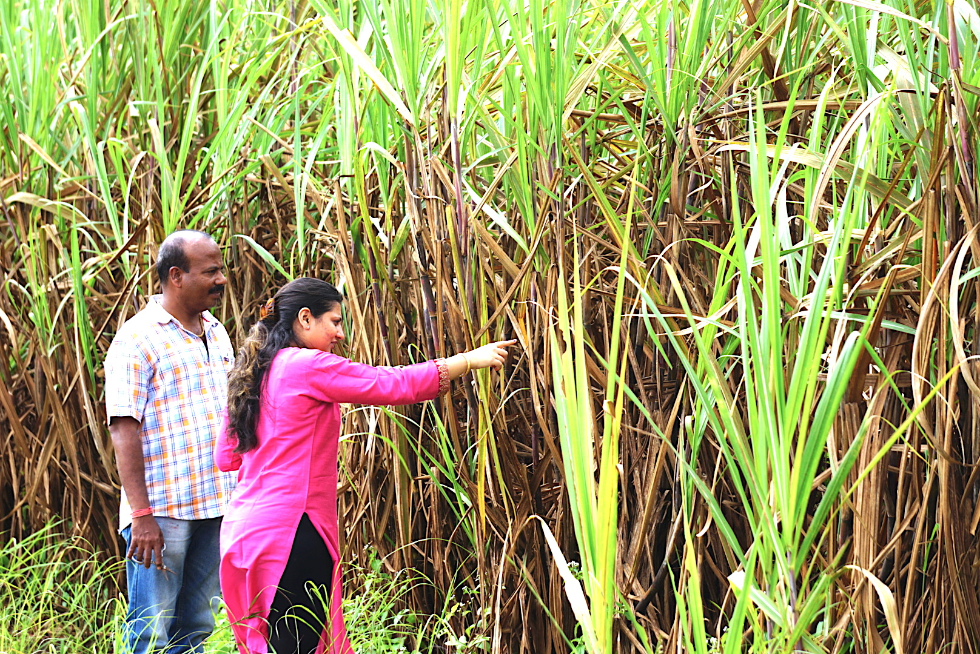

*Image: me working with a local sugarcane, farm owner for collecting data samples.*

**Monitoring crop health using drone images**

**12.3.2019**

Swaroopa Kadam

**University of North Texas**

**Overview** **3**

**Goal** **6**

**Exclusion** **6**

**More details on diseases found in the sugarcane plant** **7**

Rust disease 7

Sugarcane Woolly Aphid 9

Red rot disease 9

Leaf scald disease 10

**Literature review** **11**

**Research question and Hypothesis** **15**

**Analysis** **16**

Data collection 16

Analysis of dataset 17

Data preparation 18

Labeling images using One-hot encoding 20

Creating matrix representation for each image. 21

Randomize training data 22

Normalize the image data by dividing with 255 23

Modeling 24

Model training 29

Optimization using HSV format 30

Optimization by increasing epochs 31

Model testing 33

**Recommendation** **35**

**Conclusion** **36**

**References** **36**

# **Overview**

In recent years drones have gained a lot of popularity. These unmanned aerial vehicles (UAV) are successfully being used in logistics, transportation, photography, law enforcement, surveys, and agriculture (Wang L. et al, 2019) sectors. The most popular feature of a drone is its ability to capture high quality images from the top, popularly known as aerial photography (Koh and Wich, 2012). This project aims to use the photo capturing ability of drones to survey agriculture fields and monitor the health of the crops. Closeup photos of plant leaf will be captured by drones. I will use the OpenCV library of Python for pre-processing images (Wang Z. et al, 2018). Then I will use Convolutional Neural Networks (CNN) to create a data model that can detect crop diseases by analyzing the plant leaf images captured by a drone.

I have selected the sugarcane crop for our study. Sugarcane is the world's largest crop by production quantity, with 1.8 billion tones produced in 2017 (FAOSTAT, 2017). The Food and Agriculture Organization estimated sugarcane was cultivated on about 26 million hectares (64 million acres), in more than 90 countries (FAOSTAT, 2017).

The following map shows sugarcane producing countries and approximate production. *Source - FAO online data visualization tool (http://www.fao.org/faostat/en/#data/QC/visualize).*

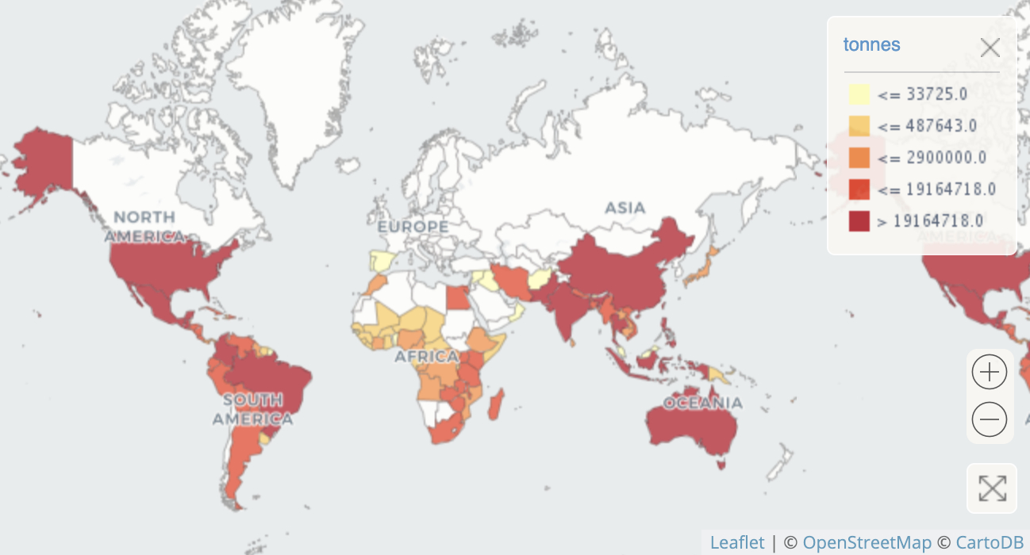

Sugarcane crop is not an expensive crop, so, to keep it profitable, it has to be produced in large quantities. Due to this the sugarcane farms are very large and are densely cultivated, making it difficult to walk-in and monitor each plant (Yadav and Prasad, 1997). This affects the disease monitoring ability of the farmer.

The following image shows the density of a sugarcane farm.

The most important aspects of the sugarcane crops that a farmer needs to take care of are:

1. **Disease control:** Sugarcane diseases can be devastating as the disease spread very fast. Due to the high density of the field farmers generally, realize the disease quite late.
2. **Proper Irrigation:** Maintaining a regular supply of water as the sugarcane plant needs a lot of water to increase its weight and sugar content.

Both of these factors can be monitored using an aerial view captured by a drone. Automating this process can help farmers to monitor large fields daily. This can help the farmer to take immediate action to fix irrigation problems and controlling diseases. Due to large scale production, our model for detecting sugarcane diseases will be very useful in the field and will also build a strong case in favor of the commercialization of this technology.

# **Goal**

The primary goal of this project is to create a deep learning-based **image classification model** that can classify plant leaf images into the following categories:

1. A Healthy leaf.
2. Infected by rust disease.
3. Infected by Red Rot disease.
4. Infected by Leaf scald disease.
5. Infested by Sugarcane Woolly Aphid.

I will use CNN (Convolutional Neural Network) for creating the image classification model. CNN is a type of Deep Learning Model that was initially used by Facebook for detecting faces in images (Hazelwood et al., 2018).

# 

# **Exclusion**

The following functionality will be excluded from this project as this will be developed separately by the Drone manufacturer.

1. Drone and camera hardware with internet connectivity.
2. The Setting up of drone and testing it on farmland. This is a long testing process and will be carried out separately to increase the accuracy of the CNN model.
3. Extracting individual leaf from a large image taken by the drone. This is an image processing related task and does not affect the image classification model. So this software will be developed separately.
4. Sugarcane diseases apart from the 4 diseases are excluded from this project as these are the diseases that have a major impact on the Indian subcontinent. If we are able to successfully reject the Null hypothesis, the project will expand to include other diseases as well.

# 

# **More details on diseases found in the sugarcane plant**

# Rust disease

**Image:** Sugarcane leaf having Rust disease

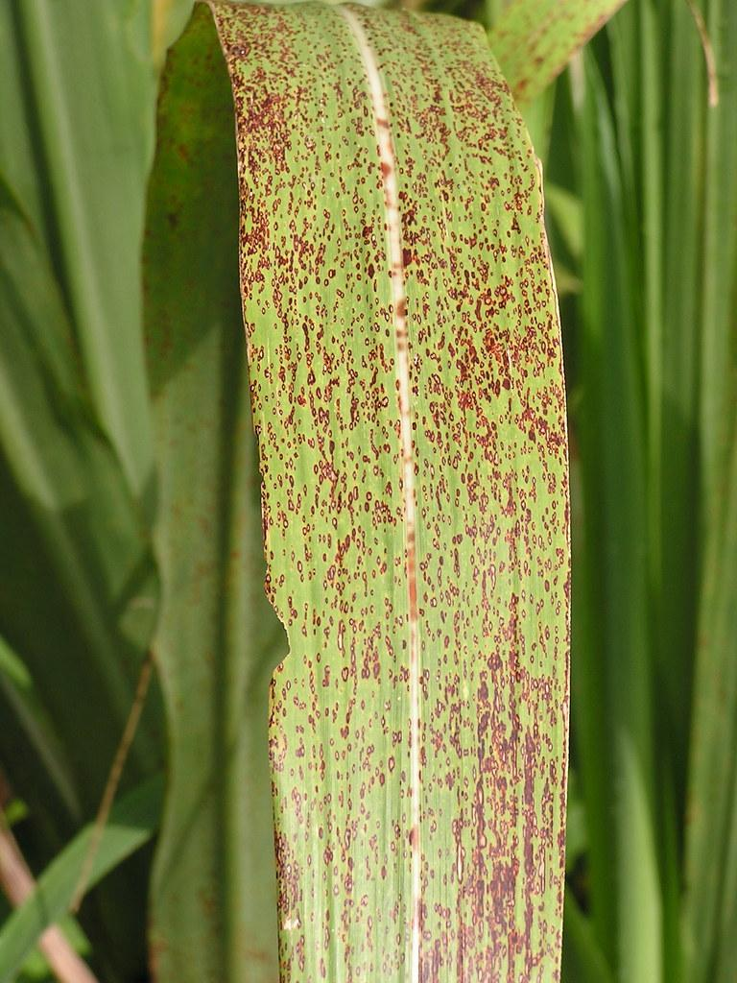

Rust is a type of disease which we can see on the leaf of the sugarcane crop, sugarcane rust is caused by the pathogen **Puccinia Myelencephalon.** This disease can be identified by the small yellow spots about 1mm to 4mm in length, As the disease starts spreading the spots are elongated lengthwise and starts turning reddish-brown in color. This then gives rise to Uredospore’s. Uredospore’s are the infectious spores of pathogen **Puccinia Myelencephalon**. These spores are found underneath the epidermis where the leaf spots are present. The large and irregular area of tissue results in the premature death of sugarcane leaves.

## Sugarcane Woolly Aphid

**Image:** Sugarcane leaf having **Sugarcane Woolly Aphid**

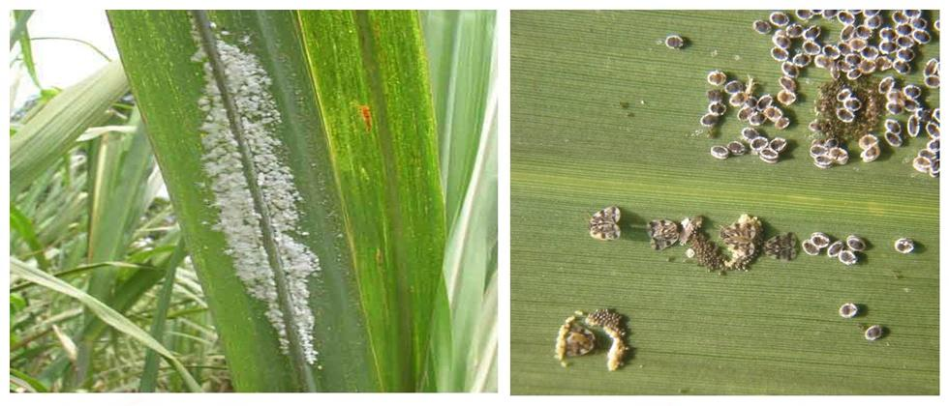

Sugarcane wooly aphid is a pest that sucks healthy green leaves. Whereas Aphids are small sap-sucking insects that have a white and fluffy appearance. According to studies, Aphids are known to be the most destructive insect pests on cultivated plants. This type of pest is mainly found in India, Nepal, Bangladesh, throughout East and Southeast Asia, Fiji and the Solomon Islands.

## Red rot disease

This is also known as the cancer of sugarcane as the entire crop is destroyed within a few days due to this disease. This disease is caused by the fungus **Colletotrichum Falcate**. The first external evidence of this disease is drooping, withering, and finally yellowing of the upper leaves. The affected leaf appears to have reddish lesions. These lesions are 2 to 3 mm in length and about 0.5 mm in width.

**Image**: Below is the image of a sugarcane leaf infected by red rot

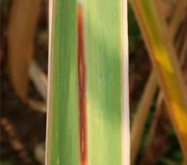

## 

## Leaf scald disease

Leaf scald is a fungal disease, this disease is caused by a fungal pathogen called **Microdochium Oryzae.** It can be identified by dark brown patches that are found on the leaf surface of the sugarcane plant. These patches are about 1−5 cm long and 0.5−1 cm wide or may almost cover the entire leaf. The leaves affected by this disease dry out and give a scalded appearance. This type of disease mainly occurs in the rainfed regions of Asia, Africa, and the U.S.

**Image**: A sugarcane leaf infected by leaf scald

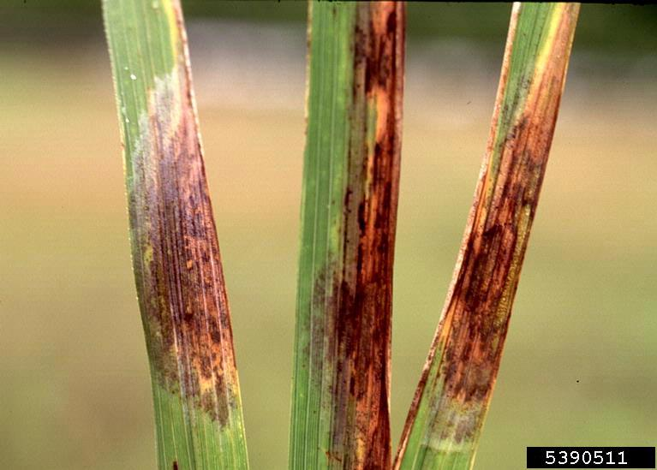

# **Literature review**

A paper by Arifa Khan (Khan et al., 2017) worked on image processing to detect diseases in the leaves of sugarcane plants. Researchers have studied the red rot disease, leaf scald disease, and mosaic disease that are most commonly seen on sugarcane leaves. For the study of images, only the “color” feature was used to classify the images. The images were converted into HSI (hue, saturation, intensity) format to reduce the effect of brightness on the image features. This paper then used the technique of K-means clustering which would make a cluster of images based on the intensity of hue and saturation. With the help of this technique, the researchers were able to segregate the images based on a few factors of color. This research has a few limitations like the inability to detect texture in the image. For example, if a red color paint was spilled on the leaf of the sugarcane plant, this technique would give a misleading prediction of the leaf suffering from the red rot disease. Also, the shape of the stain is an important feature that this technique misses out. In my research study, I will use the CNN technique which can capture many more features like texture, shape, and spread of the color and give more accurate results (Hazelwood et al, 2018).

A notable paper by Prof. Dhaygude and Kumbhar provides recommended the best practices and steps to follow when performing an image-based classification of plant leaves (Dhaygude and Kumbhar, 2013). Researchers recommend converting images into HSV (hue, saturation, and value) format. Based on the research HSV format is the most effective format for capturing maximum features from a plant leaf image. The following image compares RGB (red, green, blue) and the HSV format of images. We can see that it is easier to identify features in the HSV image. In Hue(H) the image on the right, we can see that the mountains show certain red and yellow spots that are not seen in any of the red, green or the blue color channels in the RGB format. In Saturation (S) image, we can see that the dark shadow patches on the house are showing some details instead of just black color.

**Image:** Comparison of HSV and RGB image format. 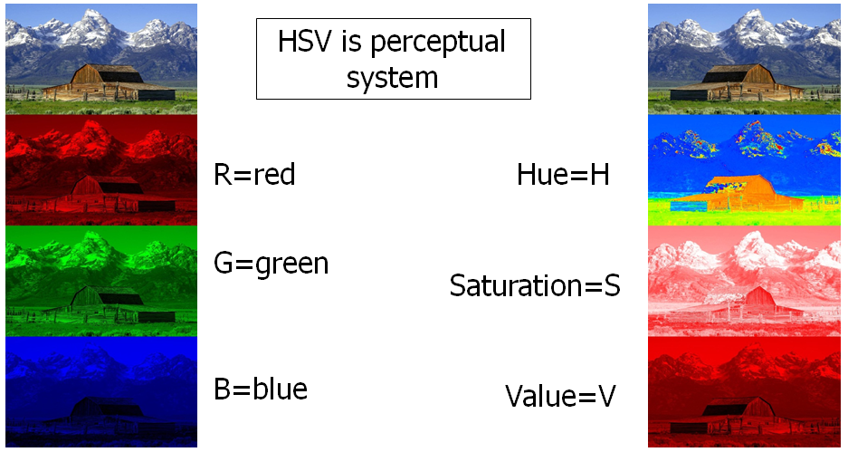

There is one more paper that suggests using the HSV format for working on plant-related images (Priya, and D’Souza, 2015). This article works on detecting diseases and the quality of fruits using image analysis. Based on this I can say that the HSV image format is more effective for CNN modeling, and I will use this in my project.

One more important step that the paper by Prof. Dhaygude and Kumbhar recommends when performing image-preprocessing is to mask and remove green pixels. This is a great idea that I had not thought of. Researchers suggest setting the value of the pixels that are in any shade of green to zero. This step can be very effective in increasing the accuracy of our classification model as the majority of the color of the image will be green. Removing the green color will help to reduce the large volume of data that is of no use. I think by only focusing on non-green pixels we can locate diseases much faster and with better accuracy. I would be able to evaluate the effectiveness of these techniques once I implement the CNN model.

A paper by Howard, A. G. (2013) explains how we can effectively use the CNN image classification technique. This is important for this project because the CNN modeling technique is infamous for using a lot of computing power (Hazelwood et al, 2018). This paper will help me in optimizing my input images and tweaking the classification model for the best accuracy and optimal performance. The paper suggests taking a random crop of the training images and then feeding it as additional training images. This method can greatly reduce the problem of model overfitting. By removing the cat’s face from the following image, the CNN model will be able to classify the image as a Cat image even if a small part of the image is provided to it. Additionally, we can flip the images horizontally, change the image brightness, color, and saturation and feed the new images as the training dataset. This will reduce the dependency on proper lighting and the direction of capturing the testing images.

**Image**: by random cropping, we can hide certain features of the image and help in reducing overfitting.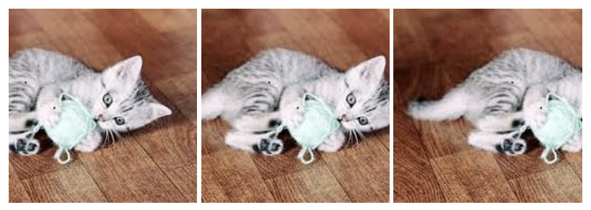

The classic paper on ImageNet classification (Krizhevsky et al., 2012) using the CNN modeling technique is relevant even now in understanding the underlying concepts of the CNN model. This paper discusses the use of a basic CNN model to classify images from the ImageNet dataset. The ImageNet dataset contains 15 million labeled high-resolution images belonging to roughly 22,000 categories. These images belong to random categories like animals, buildings, flowers, food, etc., still, the CNN model was able to classify these images into correct categories with reasonable accuracy. In my project, I will be using only one category of images, which is the images of plant leaves. The ImageNet paper (Krizhevsky et al., 2012) supports and brings confidence in me that CNN modeling techniques can be effectively used for detecting sugarcane plant diseases based on the images of its leaves.

Aerial images are being used for wildlife counting and habitat management. Aerial images are commonly used to estimate the number of wildlife species like arctic seabirds (Laliberte and Ripple, 2003). Aerial videos are also used to study the habitat of wildlife (Sidle and Ziewitz, 1990). Researchers are working on using Machine learning for classifying forest, its biodiversity and analyzing the changes in the forest using drone images (Li et al., 2013). The current use of drones in forestry applications is still at an experimental stage, but with great potential in the near future.

Image processing is also popularly being used in the field of agriculture. Systems are being used that can classify fruits into grades and separate out spoiled fruits by using images captured on a conveyor belt that carries the fruits. Other applications that are under research are in the area of weed detection in the farms and the estimation of weed coverage (Vibhute and Bodhe, 2012). Aerial images are also used for estimating corn grain yield (Shanahan et al.,2001). Insurance companies are experimenting with drone images for completing surveys to estimate crop damage when providing insurance benefits to the farmers. The use of images in agriculture is at its primitive stages and we can expect tremendous growth in this field in the near future.

# **Research question and Hypothesis**

Research question

**Can an image classification model effectively detect Sugarcane plant diseases?**

The research tries to build an image classification model using deep learning techniques that can effectively classify sugarcane leaf images into Healthy, infected and can detect the exact type of infection.

Null Hypothesis

An image classification model using Convolutional Neural Network cannot effectively detect sugarcane plant disease based on the image of the plant leaf.

Alternate Hypothesis

Using modern image classification deep-learning modeling techniques, we can build a model that can effectively detect sugarcane plant diseases based on the image of the leaf.

# **Analysis**

## Data collection

I have collected a total of 18,000 sugarcane leaf images by conducting visits to nearby sugarcane farms and from google images. There were no specific images collected by any institution in large number, so I had to gather the images myself. The images were collected using an iPhone and Sony DSLR cameras. As this is a pilot project to test the capability of the classification model, I have not used drones for capturing images.

The images collected are a mix of infected and healthy leaves. Around 14500 sugarcane leaf images will be used for training the CNN model and 3800 images will be used to test the accuracy of the model. This is approximately 80-20 split between testing and training data.

**I am using Google images as my Image repository:**

<https://photos.app.goo.gl/fwHfsncR7DyqFrEA9>

## Analysis of dataset

All the images had three channels, Red, Green, Blue, popularly known as RGB format. The images collected were of large size. The image dimensions ranged from 1080x1616 to 3024x4032 pixels. I had to cut off small parts of the image and resize the images to 100x100 pixels before using them for building the classification model.

**Image**: details of initial images collected.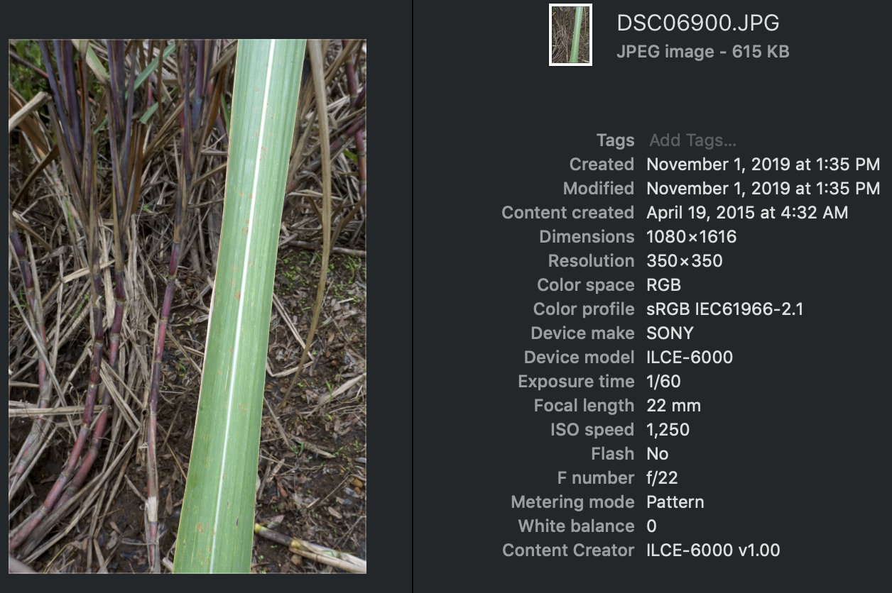

The collected images were systematically organized into folders representing the classification for training the image classification-model.

**Image:** organization of image files into various categories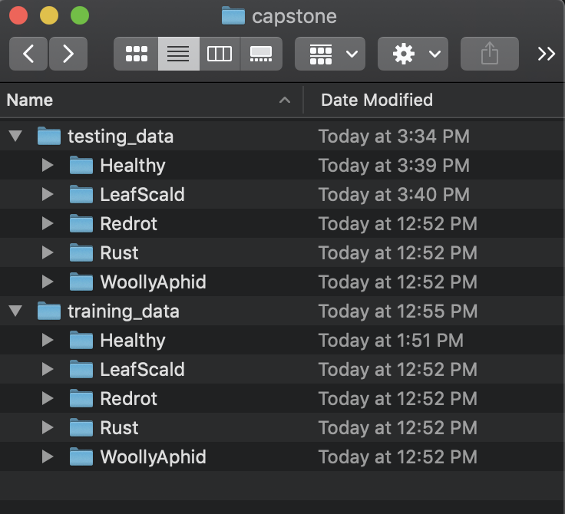

## Data preparation

CNN classification models consume a lot of hardware processing power. So, to limit the processing requirements I had to convert the images to the size of 100x100 pixels without losing any details. Most of the projects use 32x32 size images with CNN, so, 100x100 images size is enough for this application. To ensure details are not lost around 200x200 pixel screenshots from the original images were captured. In a real-world scenario, we will have a program to perform this action, but I had to do this preprocessing step manually. Later using OpenCV based program the images were resized to 100x100 size.

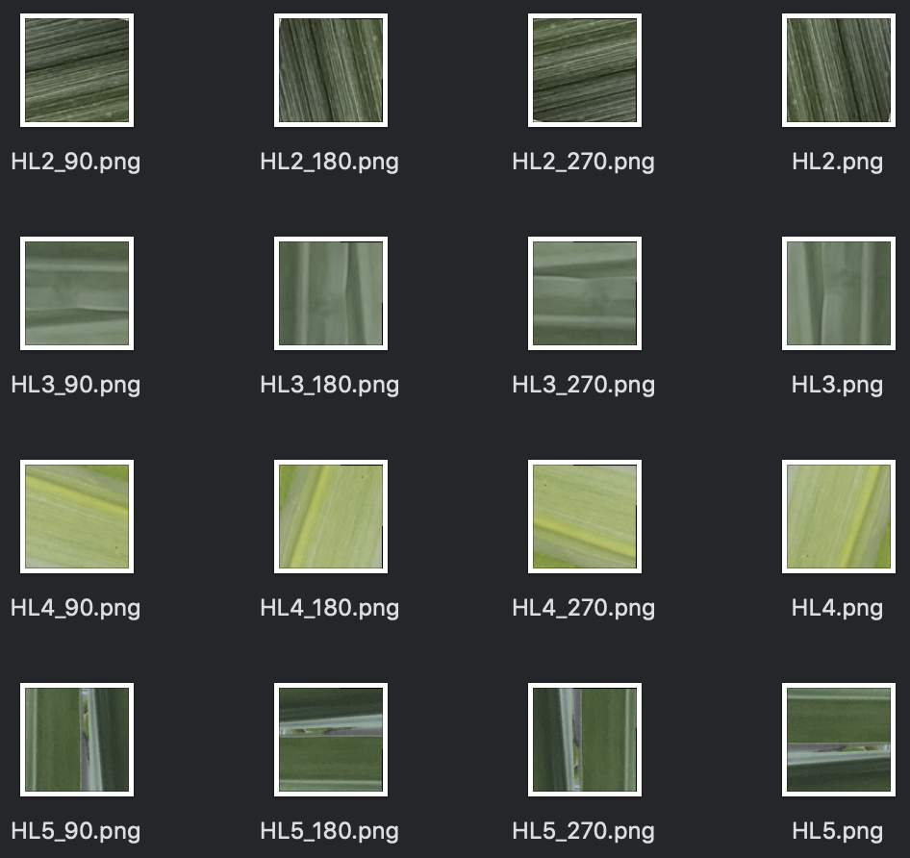

Additionally, to remove any overfitting due to the orientation of the images, I have rotated the images by 90, 180 and 270 degrees. The file names are appended by _90, _180, _270 to record the orientation change.

### Labeling images using One-hot encoding

The images are labeled using a one-hot format encoding as required by the CNN modeling technique. This helps in labeling training data with the classification of the image. Following is the one-hot encoding, observe that each category gets a distinct 1 in the four-digit label.

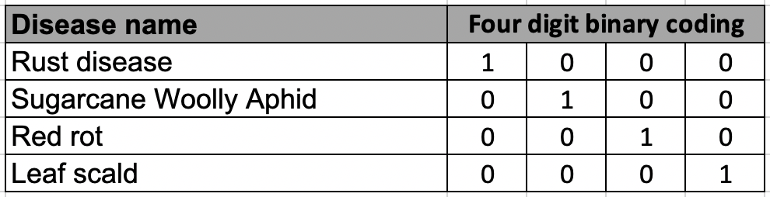

For our image classification model, we will be using the five-digit label as we have 5 categories for classification. Following is a screenshot of images with their one-hot encoded labels on top.

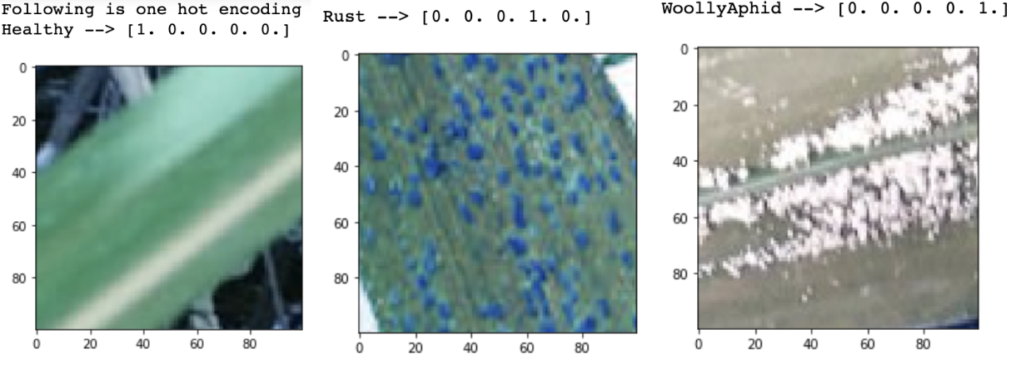

### Creating matrix representation for each image.

We are using TensorFlow for creating our CNN model. We need to convert each image into a tensor of size 100x100x3. 100x100 is the 2D dimension of the image and 3 represents the number of channels (e.g. RGB). each pixel is represented by a number in the matrix with a value ranging from 0 to 255. For example, if we consider the red channel, then a pixel with value 255 means the pixel is of red color. A pixel with value 0 means the pixel in the image is of black color. If a pixel has any value between 0-255 in the matrix, then it represents a different shade of red.

**Image**: Training data is created by converting all the images into 100x100x3 tensor.

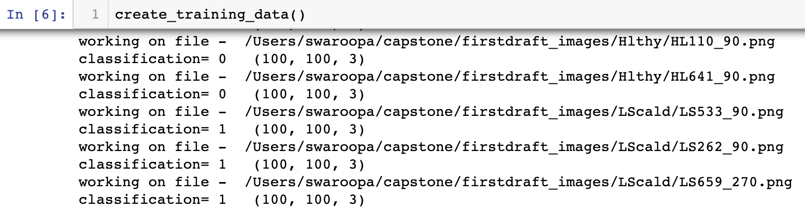

**Image**: following image demonstrates how an image channel (grayscale in this example) is represented in a 2D matrix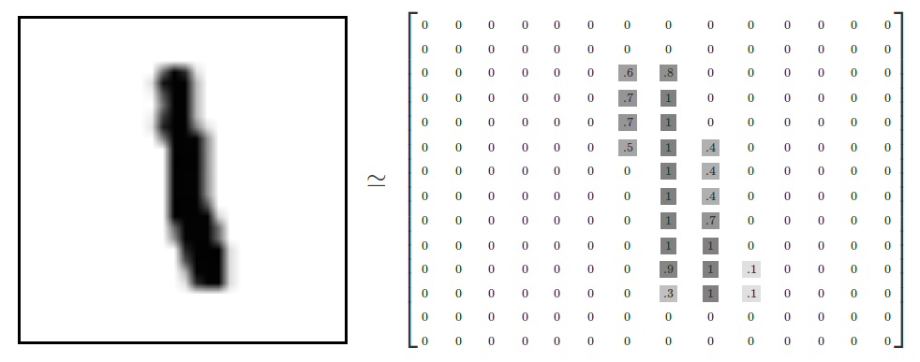

### Randomize training data

When the images are imported in the form of a list, all the categories of classification were imported one after the other. Since each category of the image was clustered together in the training data, there was a risk of generating weights that may be biased (Batista et. al, 2004). So, the image class categories were randomized in the input list to create a mix of categories. The following python function was used to randomize the input list

training_data:

random.shuffle(training_data)

### Normalize the image data by dividing with 255

The next preprocessing step was to convert all the numbers in the image tensor to values between 0 and 1. This was done by dividing each pixel value representation by 255.

**Image**: Normalized matrix, which has all values between 0 and 1.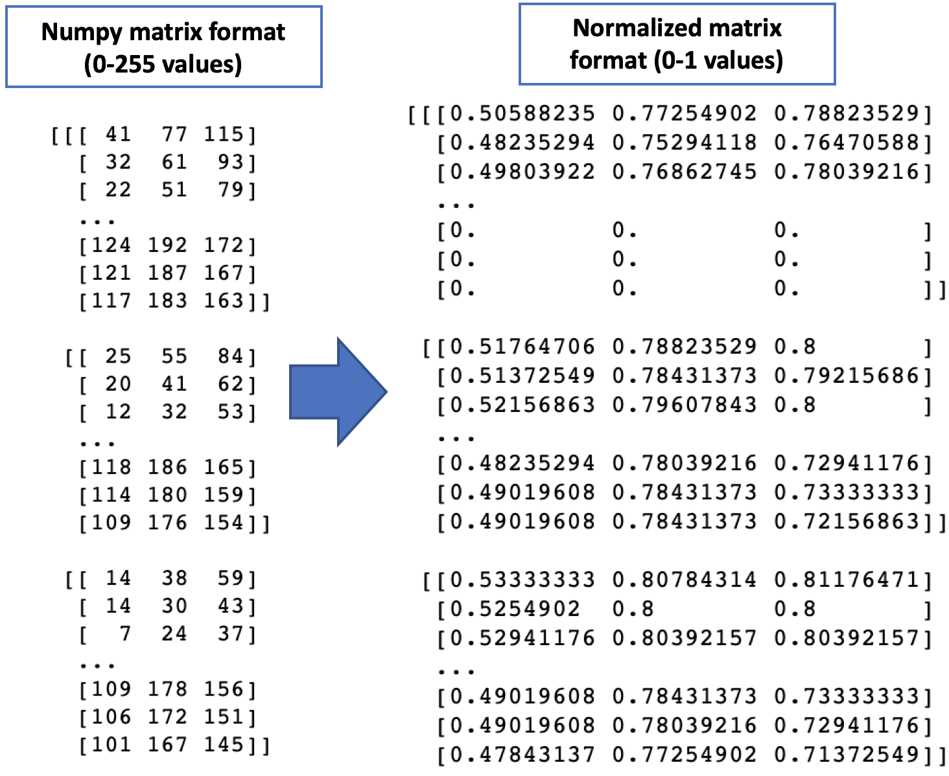

After normalization, the training data is ready to be used for training the CNN image classification model.

## Modeling

I am using Keras TensorFlow library to implement the Convolutional Neural Networks (CNN). The CNN model is using training and testing images data in a ratio of around 80%-20%. A deep learning CNN model takes an image input in the form of a 2-dimensional array of pixels. Each pixel of the image is treated like a number representing the RGB color combination for that.

**Image**: the following image shows the representation of a color image in the form of a 2D matrix.

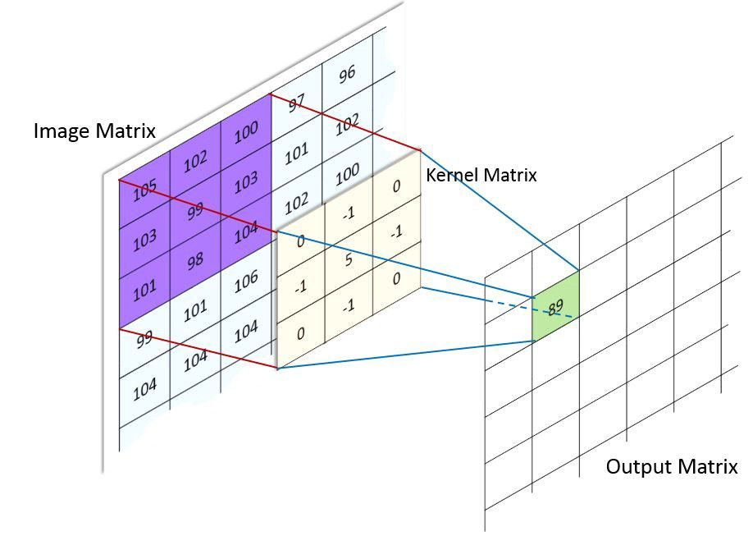

Once the image is converted into a 2D array of numbers then multiple rounds of Convolution and max pooling function are applied on the array. The 2nd layer on top with the number 89 is created as a result of the convolution function applied on the 2D array. Every time the convolution function is applied, the distinct feature of the image is captured into a pattern of numbers. For example, the “rust” disease will have numbers associated with “red” color evenly spread across the 2D matrix, but the “red rot” disease will have the numbers associated with the red color concentrated at the center of the 2D array in a specific pattern. These distinct patterns of numbers in the array help CNN deep learning model to classify images.

**Image**: Following is a diagram of the CNN deep learning model that classifies images of various animals and objects.

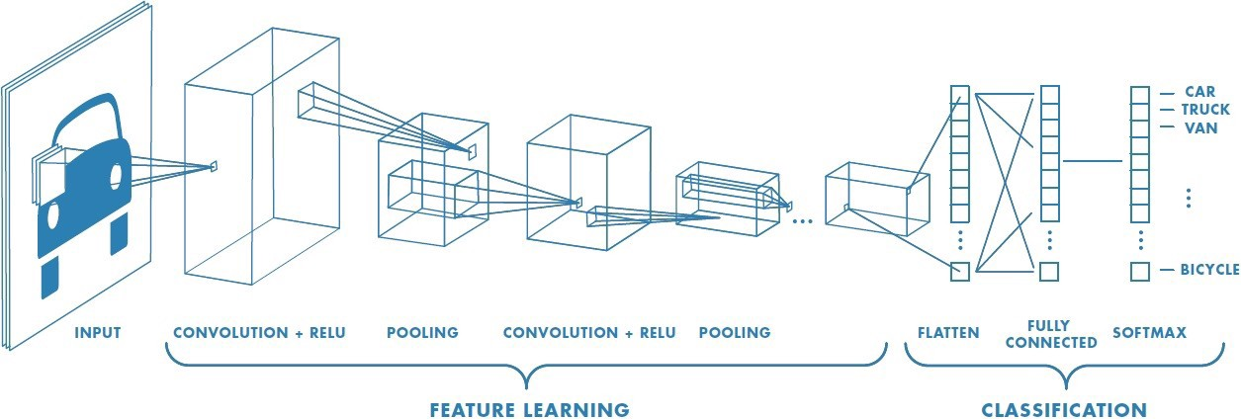

The first step in CNN is to create a layer of convolution, in this layer, a filter map of very small size (smaller than the image) is taken. This filter map hovers over the entire image and it performs multiplication with the image matrix. The product of this multiplication is given to the activation function called ReLu. The negative values that we get in the output matrix are converted to zero with the help of the ReLu function.

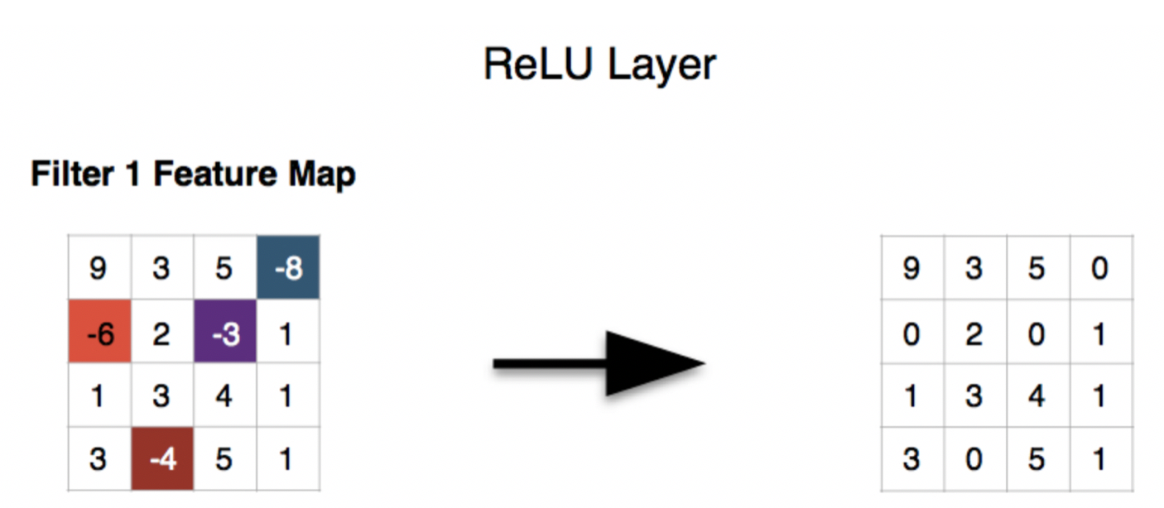

After the ReLu layer, the output is then given to the max-pooling function. Max pool function pulls out the maximum number in the given size of the filter. From the below image we can see a yellow square where we can see the maximum number is 6 this number is taken out in the feature map. This function helps in reducing the dimension of the image but keeps the same amount of depth.

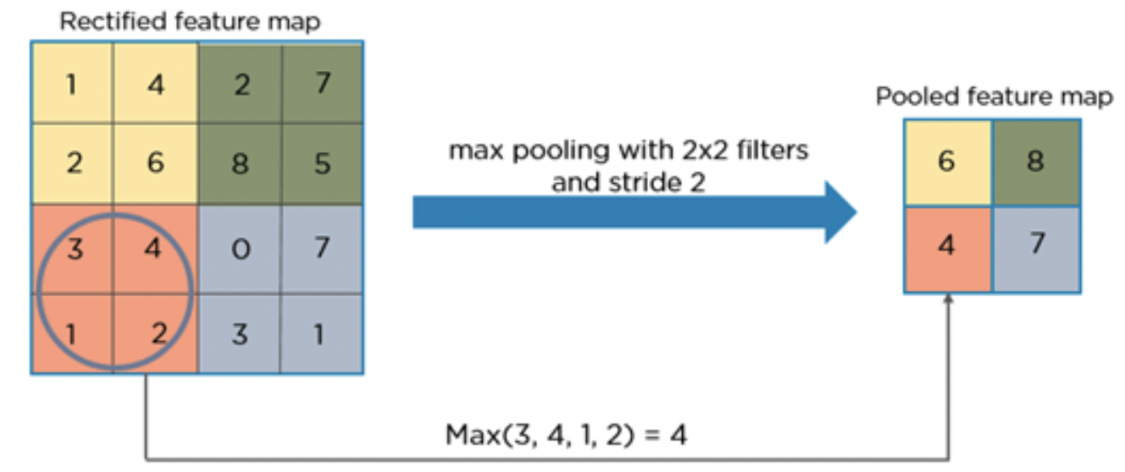

This process of convolution, ReLu and max-pooling are repeated multiple types as needed. The image matrix is then converted to a one-dimensional array with the flattening function. The output needs to be flattened as the next fully connected layer cannot take a matrix and requires a one-dimensional array to show the output.

The following screenshot shows the code in python for training our model. We are using the sequential model of the Keras library as we want to implement a sequential CNN model. The first layer in the model is a Convolutional layer with an output of 128 nodes or matrices. It uses a filter size of 3 by 3. As we have not mentioned strides, this filter is by default moved by strides of 1,1. We need to mention the size of the input image (in this case it’s 100x100) in the first convolutional layer. In the later layers, Keras is smart enough to identify the changes in size on its own. So, we do not mention the size of the image in any of the later layers.

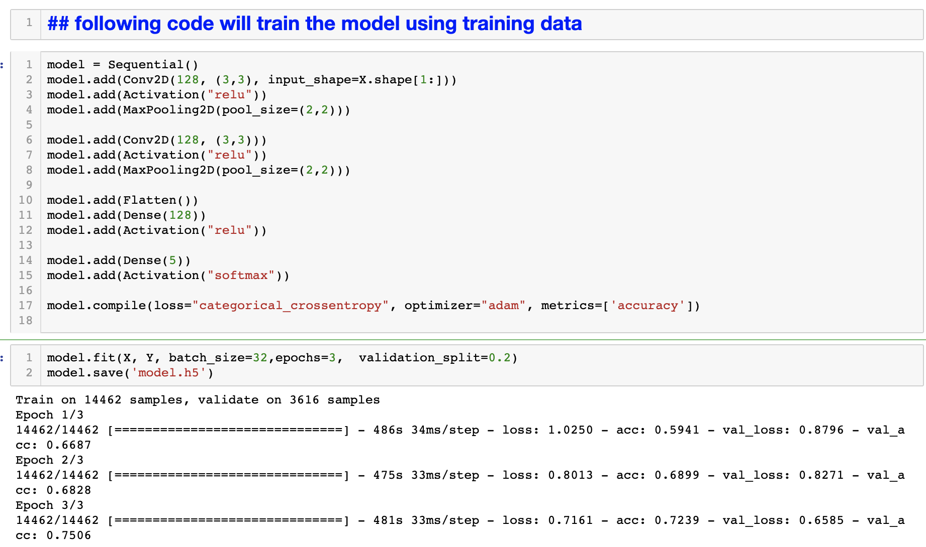

The 1st convolutional action is completed by an activation function “ReLU” which sets all the negative values to 0. And a MaxPooling layer that helps us reduce the size of our image matrix without losing the details. From line 6 to 8 in the above screenshot, a similar convolution function is applied to the image again.

The first two convolutional layers deal with capturing features from the image. The next two layers work on image classification based on the captured features. We use Flatten () function to convert the multidimensional tensor into a 1-dimensional array. This 1D array is then provided to the fully-connected layer, called the “Dense” layer in Keras. Again, a ReLU activation function is used to remove negative values.

The final layer consists of a Dense layer of output size of 5. The Dense layer generates the probability of the image belonging to each class. This is why we keep the size of the output of the Dense layer as 5. Remember, we have 5 types of categories in our leaf images. Finally, a SoftMax function sets the highest probability out of the 5 (generated by the dense layer) to 1, keeping all others as 0. So, the output of the final SoftMax layer is always a one-hot encoded array with four 0 and one 1, representing the class prediction for a given image.

## Model training

In the previous section, I had created the CNN model using Keras library. In this section, we will train the model. The CNN models use an internal feedback loop to improve the model. This is why a CNN classification model is considered a machine learning model. The model starts with initial random weights and tries to classify images. Every time the model fails to classify an image from the training data-set the feedback loop modifies the weights used between the connected layers and retries the classification of the image. This helps the model to optimize itself after each run on the training dataset. The following image shows the use of weights (w1, w2) and its mathematical equivalent of a regression equation.

**Image**: the following image shows the weights used by a CNN model that is multiplied to the output of each preceding layer, before feeding the image tensor to the next layer.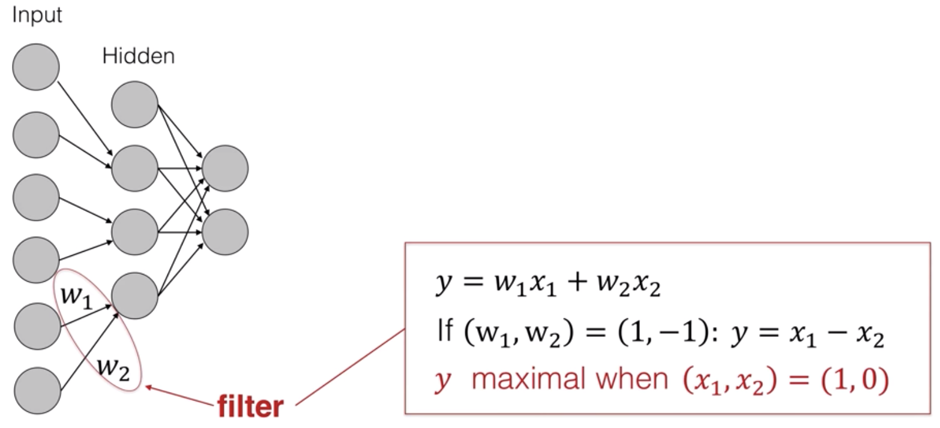

In our project, we will use 14462 training images and at the same time, we will evaluate its accuracy of prediction using 3255 testing images. We are using 3 as the epochs value, which means the model will be optimized 3 times using the same training data.

**Image**: CNN model training with **3 epochs**. Observe the increase in accuracy after each run.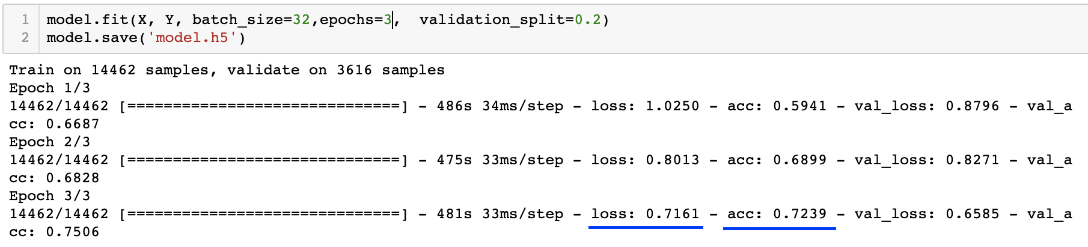

We can see that the loss (loss) reduced after each round of training, and the training accuracy (acc) increased. The training accuracy when using 3 epochs was **72.39%**

**Following graphs show that the training accuracy increased with every epoch.**

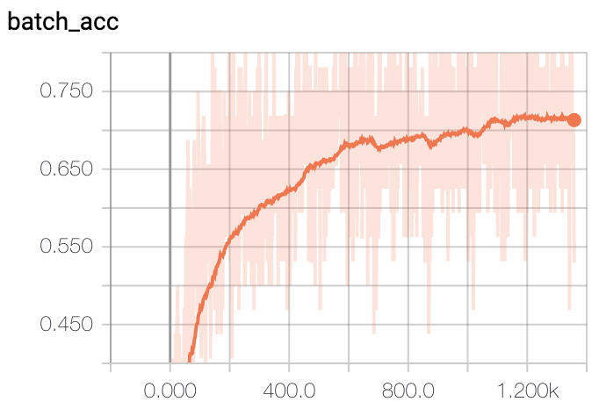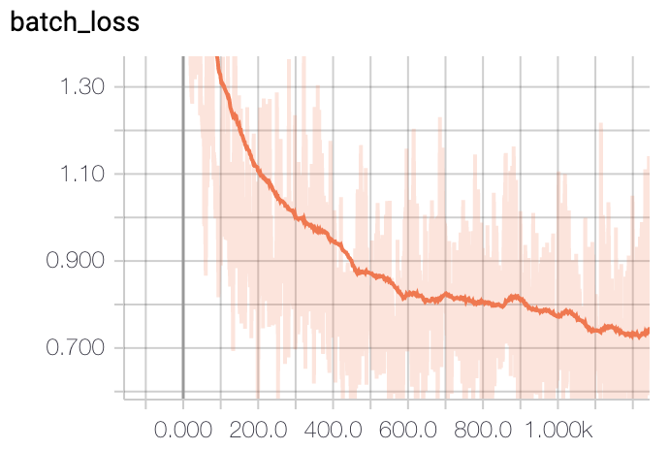

### Optimization using HSV format

In the quest of improving the accuracy of prediction, I also tried the HSV image format for classification, but the accuracy was lower as compared to the CNN model that used the RGB format of the image. Following is a screenshot of classification accuracy when using an HSV image format. We can see that by using the HSV image format our validation accuracy reduced by around 2%. We can conclude that the color of the images is an important factor for classifying the type of infection in the leaves.

**Image**: the result of training the CNN model using **HSV** image format instead of RGB.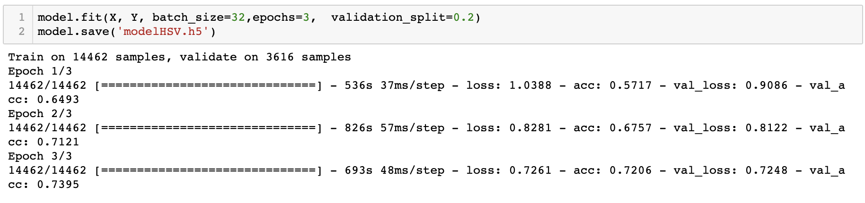

### Optimization by increasing epochs

Another popular way of increasing the accuracy of a CNN model is by increasing the number of epochs (Lawrence et. al, 2017). An epoch is the number of times the training images are used to train the CNN model. Every time we train the model, the weights of the neural network are updated to improve the accuracy of prediction. So, I tried to train the model with 50 epochs. It took around 6 hours on my laptop to complete the 50 rounds of training. After 50 epochs the training accuracy increased to 97.85%. This was a big jump in accuracy.

**Image**: training accuracy increased to 97.85% with 50 epochs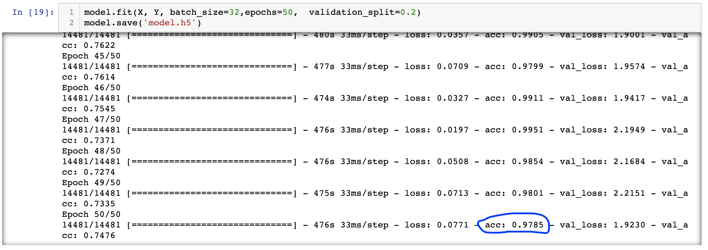

I have plotted the training progress in form of graphs using the TensorBoard library. The following graph compares the training progress of the 3-epoch and 50-epoch model. The 3-epoch model is displayed in orange color and the 50-epoch model is displayed in blue color. The Y-axis in the graph represents the training accuracy with 1.0 representing 100% accuracy. X-axis represents total number of times the model was updated in the process of training. We can see that with every round of training the training accuracy of our model increased until it reached the saturation point. So, I concluded that this is the best training accuracy I can get by increasing the number of epochs. Any further increase in the number of epochs will not have any significant impact on the accuracy of training.

**Following graph shows an increase in classification accuracy when using 50 epochs (blue) as compared to 3 epochs (orange).**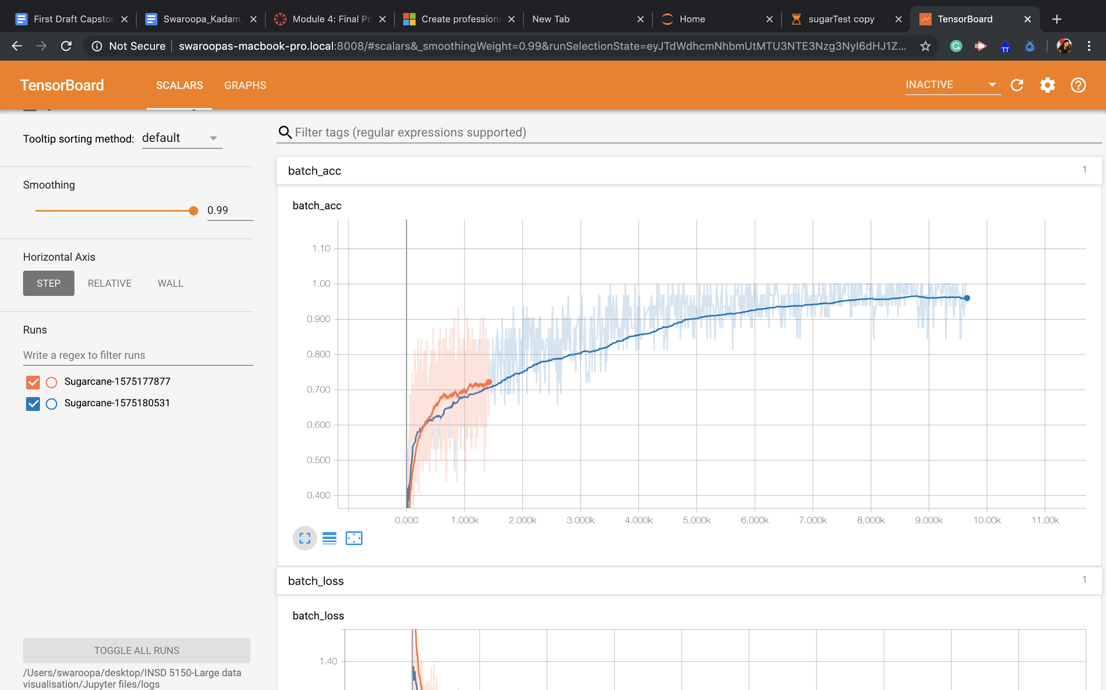

**Following graph shows a decrease in loss when using 50 epochs (blue) as compared to 3 epochs (orange)**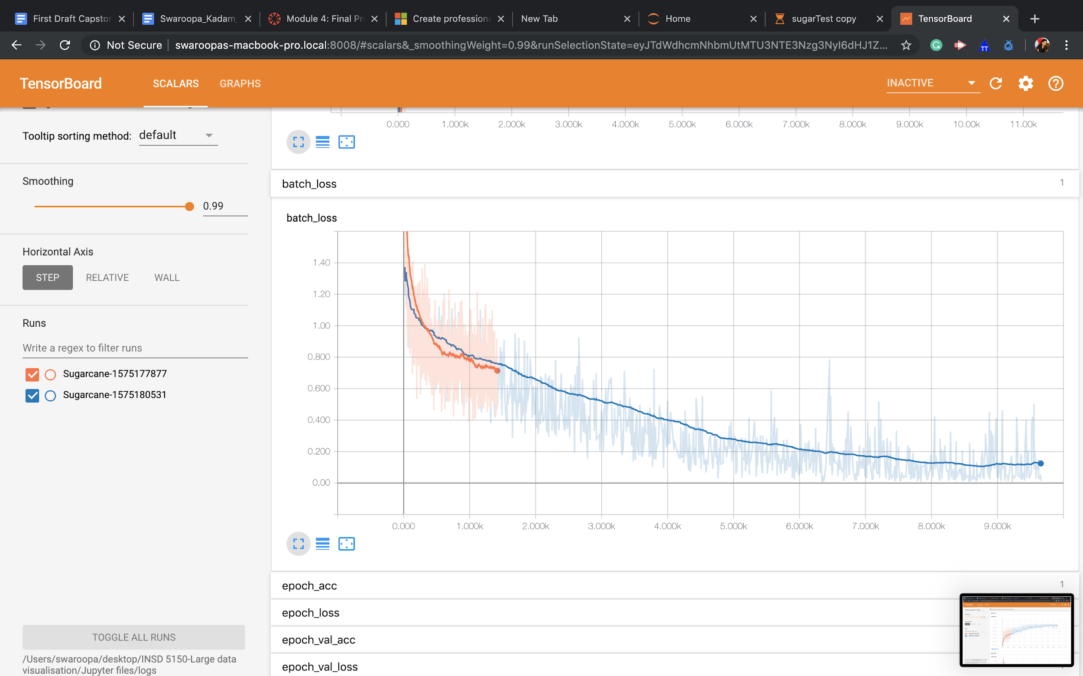

## Model testing

The next step is to test our CNN model to see how well it is classifying new images. We have provided around 144 sugarcane leaf images to the CNN model and asked it to classify the images. The following code creates an array of the input images without the labels.



Next I used the model.predict_classes() method to get classification for each image. I could capture one screenshot and we can see that the image is correctly classified into the “Leaf Scald” category.

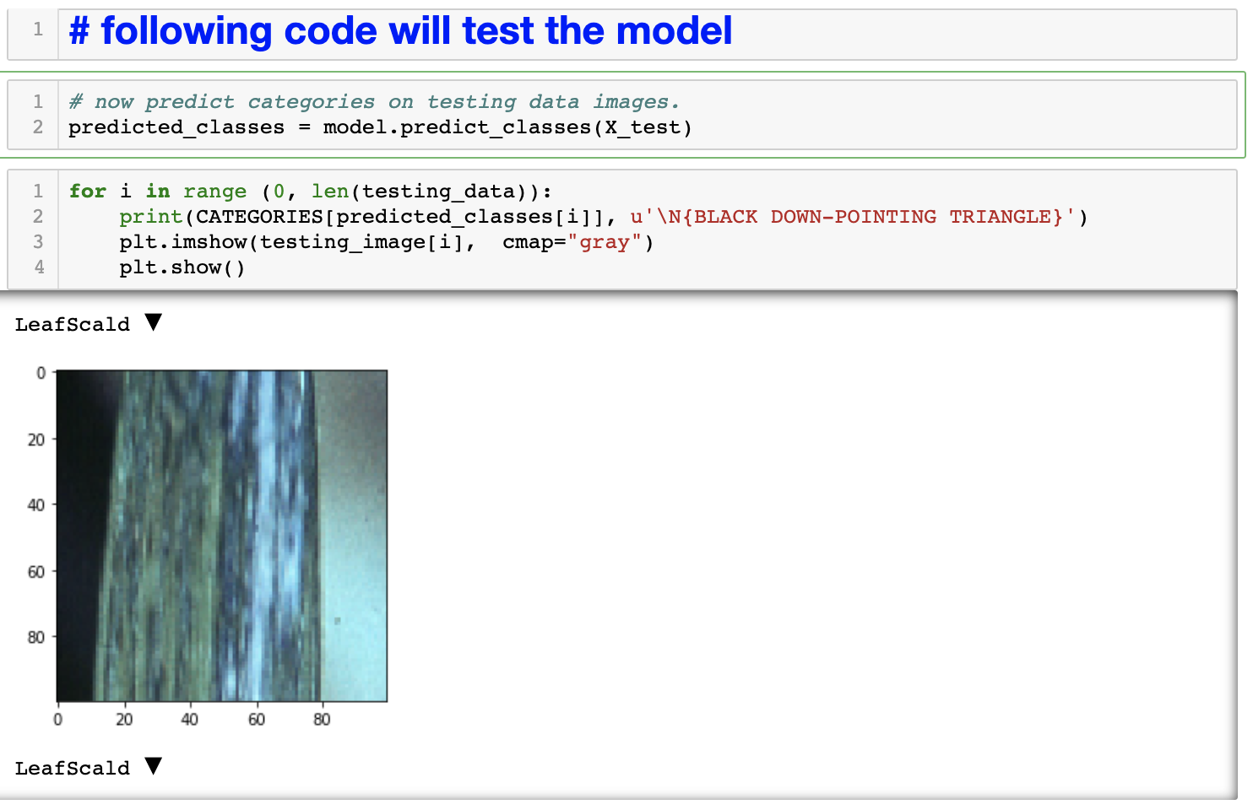

The classification model did a good job of classifying the leaf images. The python code in the following screenshot uses simple math to calculate the percentage of the images that were classified correctly. As we can see that our CNN classification model was able to identify the correct classes of leaf images with an accuracy of **89.42%**. This is a very good accuracy for the image classification model.

**Image:** Result of testing of the Image classification model using 3255 testing images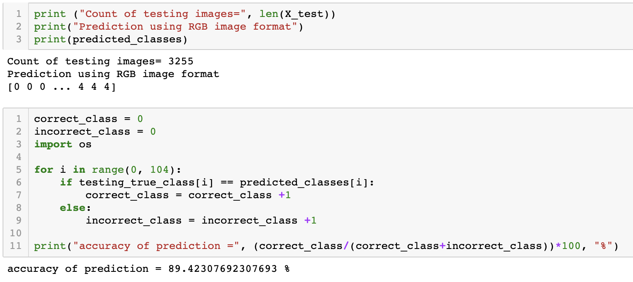

# **Recommendation**

This project used manually cropped images but when using a drone on the field there will be practical challenges (Dodge and Karam, 2016) of image focusing, lighting, the method used for cropping images, etc. For practical use, it is recommended that a lot of training considering all the possible scenarios should be performed before using this model for commercial purposes.

Recently, high-performance algorithms have been introduced which use CNN underneath but can perform classification on a live video stream from a camera (Shafiee et al., 2017). A few examples are YOLO, Faster RCNN, Masked RCNN (Biswas et al., 2018) etc. I recommend using these algorithms as the drone is a fast-moving machine with limited flight time. So, a faster algorithm will be an ideal fit for using with the drone.

# **Conclusion**

In this paper, we have discussed the details of the process and the analysis performed for creating an image classification model, for detecting sugarcane plant diseases. In the first round of our tests, we got a training accuracy of 72.39%. I also tried using HSV image format, but the accuracy was reduced. So, the HSV image format did not help in improving the model accuracy. Finally, by increasing the number of epochs to 50, I was able to get a training accuracy of 97.85%. When testing this model with a set of 3255 random images, I got a classification **accuracy of 89.42%**. This is a very good accuracy for a limited number of the image dataset. For practical purposes, we will have to collect a much larger image dataset and rigorously train our image classification model. The more we train the model, the better it will get in the classification task.

Based on the analysis, we can safely reject the null hypothesis and accept that we can use a deep learning-based image classification model for identifying diseases in sugarcane leaves.

# **References**

1. Batista, G. E., Prati, R. C., & Monard, M. C. (2004). A study of the behavior of several methods for balancing machine learning training data. ACM SIGKDD explorations newsletter, 6(1), 20-29.
2. Lawrence, J., Malmsten, J., Rybka, A., Sabol, D. A., & Triplin, K. (2017). Comparing tensorflow deep learning performance using cpus, gpus, local pcs and cloud.
3. Mr. Jagan Bihari Padhy, Devarsiti Dillip Kumar, Ladi Manish and Lavanya Choudhry,” Leaf Disease Detection Using KMeans Clustering And Fuzzy Logic Classifier”, IJESTA, Volume 02, No. 5, May 2016.
4. Dan, C., Meier, U., Masci, J., Gambardella, L.M., Schmidhuber, J. 2011. Flexible, high performance convolutional neural networks for image classification. Proceedings of the 22nd International Joint Conference on Artificial Intelligence, vol. 2, pp. 1237–1242.
5. Fuentes, A., Yoon, S., Kim, S.C., Park, D.S., 2017. A robust deep-learning-based detector for real-time tomato plant diseases and pest recognition. Sensors 17, 2022. http://dx. doi.org/10.3390/s17092022.
6. FAOSTAT, UN Food and Agriculture Organization, Corporate Statistical Database. 2017. Retrieved 20 May 2018. Link - http://www.fao.org/faostat/en/#data/QC.
7. Yadav, R. L., and S. R. Prasad. "Maximizing Sugarcane Yield by Increasing Plant Population Density, Minimizing NO3‐N Leaching and Improving Soil Organic Matter in Different Crop Rotations." Journal of Agronomy and Crop Science 178.2 (1997): 117-123.
8. Hazelwood, K., Bird, S., Brooks, D., Chintala, S., Diril, U., Dzhulgakov, D., ... & Law, J. (2018, February). Applied machine learning at Facebook: A datacenter infrastructure perspective. In 2018 IEEE International Symposium on High-Performance Computer Architecture (HPCA) (pp. 620-629). IEEE.
9. Koh, L. P., & Wich, S. A. (2012). Dawn of drone ecology: low-cost autonomous aerial vehicles for conservation. Tropical Conservation Science, 5(2), 121-132.
10. Khan, A., Yadav, M. S., & Ahmad, S. (2017). Image Processing Based Disease Detection for Sugarcane Leaves.
11. Dhaygude, S. B., & Kumbhar, N. P. (2013). Agricultural plant leaf disease detection using image processing. International Journal of Advanced Research in Electrical, Electronics and Instrumentation Engineering, 2(1), 599-602.
12. Bauer, S. D., Korč, F., & Förstner, W. (2011). The potential of automatic methods of classification to identify leaf diseases from multispectral images. Precision Agriculture, 12(3), 361-377.
13. Mohanty, S. P., Hughes, D. P., & Salathé, M. (2016). Using deep learning for image-based plant disease detection. Frontiers in plant science, 7, 1419.
14. Wang, L., Lan, Y., Zhang, Y., Zhang, H., Tahir, M. N., Ou, S., ... & Chen, P. (2019). Applications and Prospects of Agricultural Unmanned Aerial Vehicle Obstacle Avoidance Technology in China. Sensors, 19(3), 642.
15. Priya, P., & D’souza, D. A. (2015). Study of Feature Extraction Techniques for the Detection of Diseases of Agricultural Products. International Journal Of Innovative Research In Electrical, Electronics, Instrumentation And Control Engineering, 3.
16. Wang, Z., Wang, K., Yang, F., Pan, S., & Han, Y. (2018). Image segmentation of overlapping leaves based on Chan–Vese model and Sobel operator. Information processing in agriculture, 5(1), 1-10.
17. Howard, A. G. (2013). Some improvements on deep convolutional neural network-based image classification. arXiv preprint arXiv:1312.5402.
18. Liu, S., & Deng, W. (2015, November). Very deep convolutional neural network based image classification using small training sample size. In 2015 3rd IAPR Asian conference on pattern recognition (ACPR) (pp. 730-734). IEEE.
19. Krizhevsky, A., Sutskever, I., & Hinton, G. E. (2012). Imagenet classification with deep convolutional neural networks. In Advances in neural information processing systems (pp. 1097-1105).
20. Biswas, A., Jana, A. P., & Tejas, S. S. (2018, December). Classification of Objects in Video Records using Neural Network Framework. In 2018 International Conference on Smart Systems and Inventive Technology (ICSSIT) (pp. 564-569). IEEE.
21. Shafiee, M. J., Chywl, B., Li, F., & Wong, A. (2017). Fast YOLO: a fast you only look once system for real-time embedded object detection in video. arXiv preprint arXiv:1709.05943.
22. Dodge, S., & Karam, L. (2016, June). Understanding how image quality affects deep neural networks. In 2016 eighth international conference on quality of multimedia experience (QoMEX) (pp. 1-6). IEEE.
23. Laliberte, A. S., & Ripple, W. J. (2003). Automated wildlife counts from remotely sensed imagery. Wildlife Society Bulletin, 362-371.
24. Sidle, J. G., & Ziewitz, J. W. (1990). Use of aerial videography in wildlife habitat studies. Wildlife Society Bulletin (1973-2006), 18(1), 56-62.
25. Li, M., Im, J., & Beier, C. (2013). Machine learning approaches for forest classification and change analysis using multi-temporal Landsat TM images over Huntington Wildlife Forest. GIScience & Remote Sensing, 50(4), 361-384.
26. Vibhute, A., & Bodhe, S. K. (2012). Applications of image processing in agriculture: a survey. International Journal of Computer Applications, 52(2).
27. Shanahan, J. F., Schepers, J. S., Francis, D. D., Varvel, G. E., Wilhelm, W. W., Tringe, J. M., ... & Major, D. J. (2001). Use of remote-sensing imagery to estimate corn grain yield. Agronomy Journal, 93(3), 583-589.